## Basic Physics

To make anything fly, you have to balance its weight by generating an equivalent force (Lift) and balance moments about its center of gravity (cg) by generating opposite moments.  
A quad-copter generates these required moments and lift force using its four rotors. generating lift is simple, but the tricky part is generating moments to stabilize the machine and generating control forces to move it to a desired location or on a desired path. To fly stable in a particular orientation, net moment about the cg should always be zero or resultant of all the forces acting on the system should pass through its center of gravity as shown in figure 11.

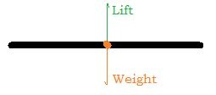

Figure 3.b: Balancing lift and weight

If the resultant of the lift generated by all the rotors doesn't pass through cg, it creates a moment about the cg and tends to tilt the quad-copter until lift again passes through the cg as shown in figure 12.

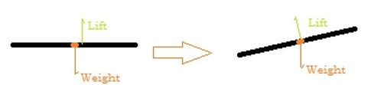

Figure 3.c: Unbalanced forces causing momentum

Also to balance the angular momentum about the cg, two rotors are made to rotate clockwise and other two anti-clockwise.

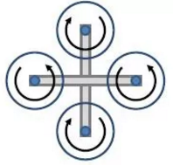

Figure 3.d: Clockwise and anticlockwise pair.